Theory of Newton’s Forward Interpolation Method

Introduction

Newton’s Forward Interpolation Method is a numerical technique used to estimate unknown values of a function from equally spaced tabulated data, especially when the required value lies near the beginning of the table. The method is based on finite forward differences and polynomial approximation. In this study, the theory of interpolation is discussed along with the derivation of Newton’s forward interpolation formula derived from Taylor’s series. A step-by-step algorithm is presented to explain the computational procedure clearly. The construction of the forward difference table is also included. Finally, a solved example is provided to demonstrate the practical application of the method.

Interpolation:

In numerical analysis, it is common to encounter situations where the exact mathematical relationship between variables is unknown or too complex to determine. However, the values of the function may be available at certain discrete points obtained from experiments, observations, or measurements. To estimate the value of the function at a point within the range of the given data, the technique of interpolation is used. Interpolation allows us to construct an approximate function that passes through the known data points and provides estimates at intermediate values.

Definition:

Interpolation is a numerical technique used to estimate the value of a function at an intermediate value of the independent variable using a set of known tabulated data points. By constructing an approximate function that fits the given data, interpolation allows us to find unknown values within the range of the available data with reasonable accuracy.

Interpolation is particularly useful when experimental data is available at fixed and equal intervals, and direct evaluation of the function is not possible or is computationally expensive. It provides a practical and efficient way to work with incomplete data.

When the estimation of the function value is carried out outside the given range of data, the process is known as extrapolation. Extrapolation is generally less accurate and less reliable because it assumes that the existing trend of the data continues beyond the known values.

Newton’s Forward Interpolation Method:

Newton’s Forward Interpolation method is a numerical technique used to estimate the value of a function at a point near the beginning of a tabulated data set. It is specifically designed for equally spaced data points, where the interval ,

Here,
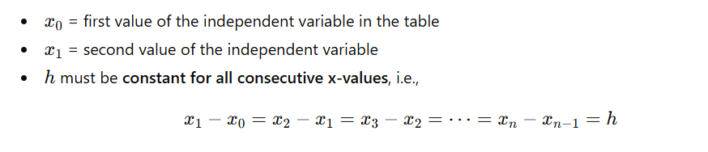

Key Features of Newton’s Forward Interpolation:

● Uses forward differences of the function values to build the interpolation formula.
● Provides a polynomial approximation of the function that passes through all known data points.
● Particularly suitable when the required value of the independent variable lies close to the first entry x0 in the table.
● Derived from the Taylor series expansion, with derivatives replaced by finite differences, which makes it computationally simple.
● The method is systematic and efficient, as it uses a triangular forward difference table for step-by-step calculation.

Applications of Newton’s Forward Interpolation:

1.Estimating function values when direct calculation is difficult

- Useful for functions that are complicated, non-linear, or not available in closed form.
- Allows approximation at points near the beginning of a data set without needing the full functional expression.
- Useful in computational physics, engineering simulations, and computer-aided design, especially for predicting outcomes near the first data points.

2.Physics and engineering problems with tabulated experimental data

- Widely used when experimental measurements are taken at regular intervals.
- Common examples include thermodynamic property tables, motion data, voltage-current characteristics, and material property charts.
- Enables engineers and scientists to interpolate values at points not explicitly measured, especially near the first data points.
3.Numerical computations in algorithms and simulations

- Often used in computer programs for modeling and simulations where discrete data is available.
- Useful in computational physics, engineering simulations, and computer-aided design, especially for predicting outcomes near the first data points.
4.Data analysis and prediction

- Helps in estimating missing or unknown data points near the beginning of a dataset.
- Supports trend analysis in time series or sequential data where early values need estimation.

Conditions for Using Newton’s Backward Interpolation Method

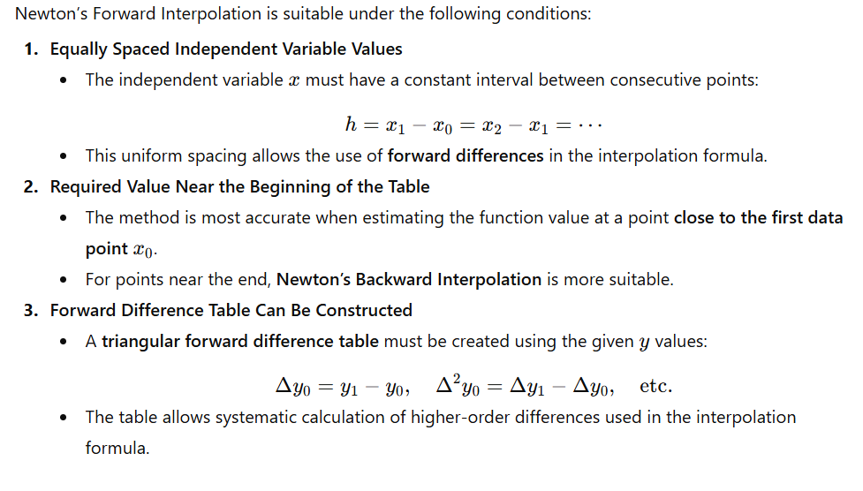

Derivation of Newton’s Forward Interpolation Formula

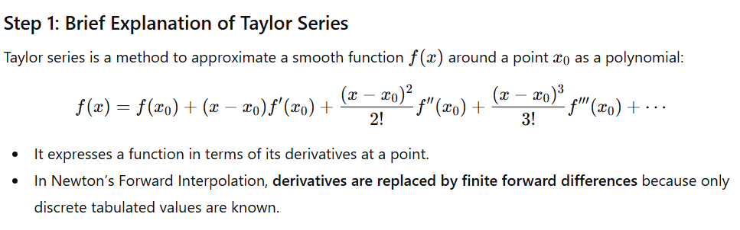

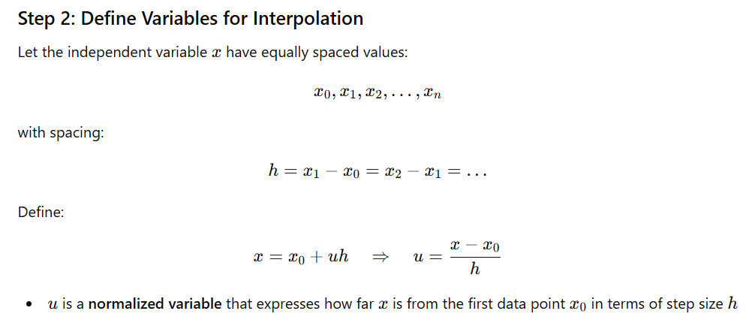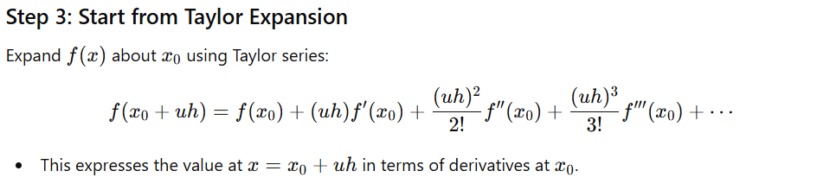
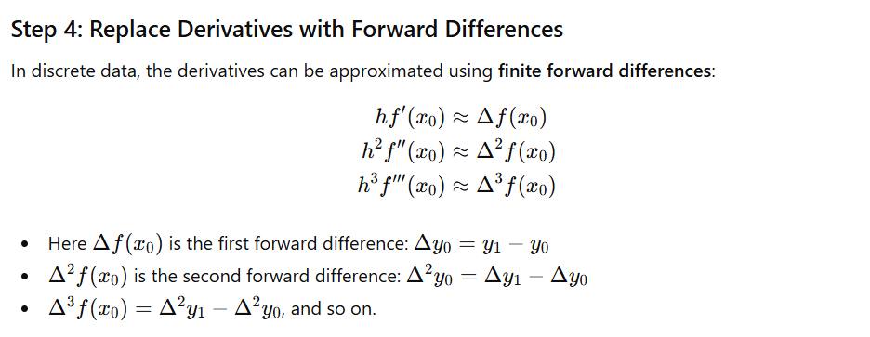

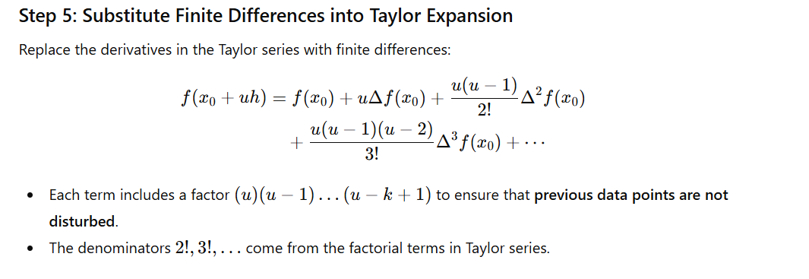

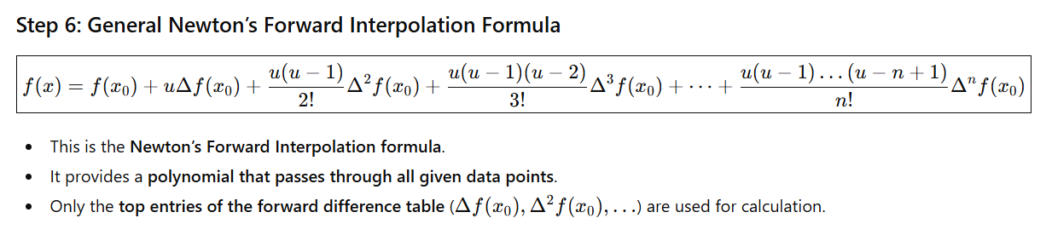

Algorithm: Newton’s Forward Interpolation Method

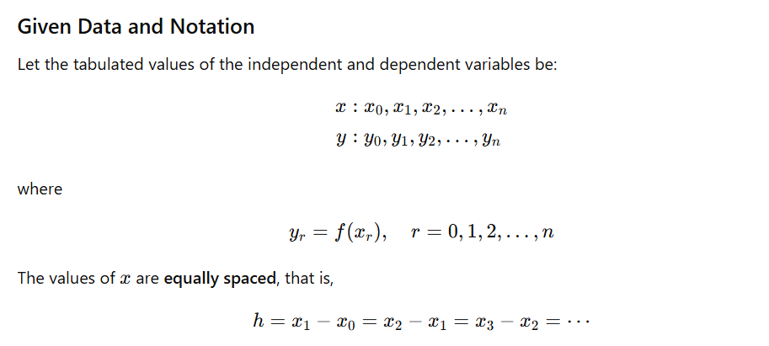

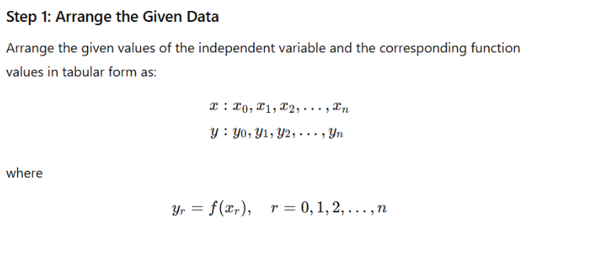

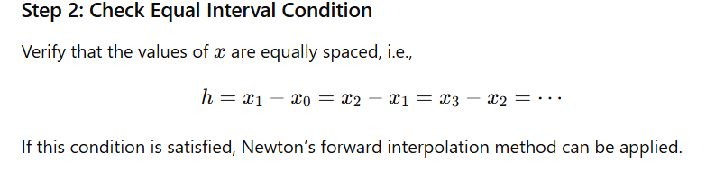

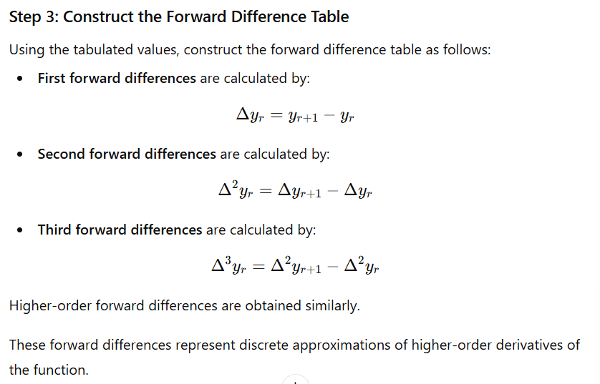

Newton’s Forward Difference Table:

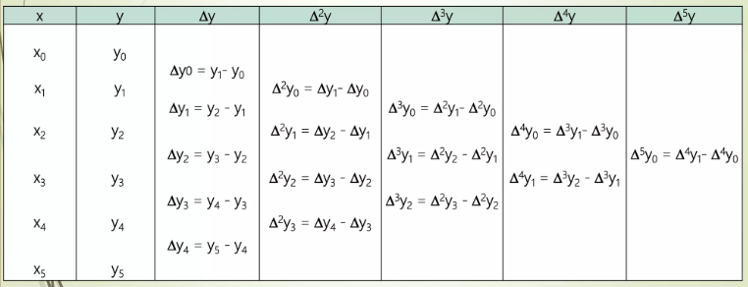

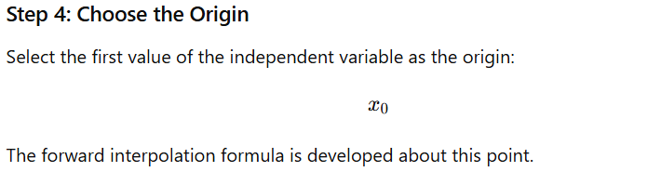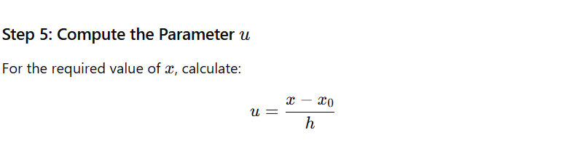
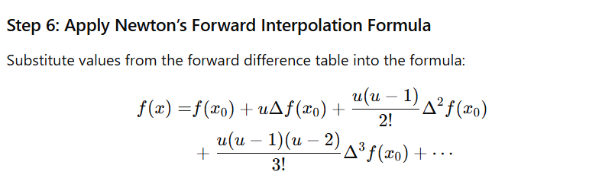

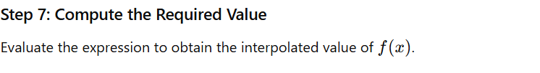

Example

Problem :

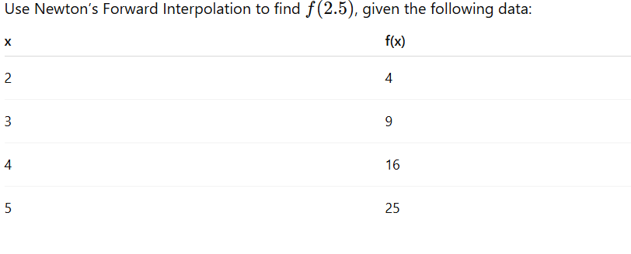
Solution :


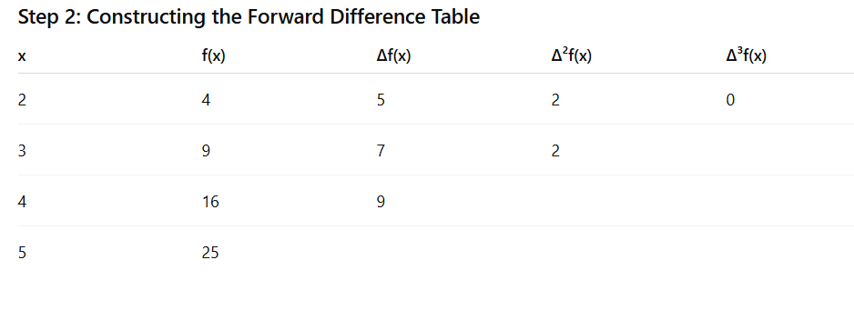

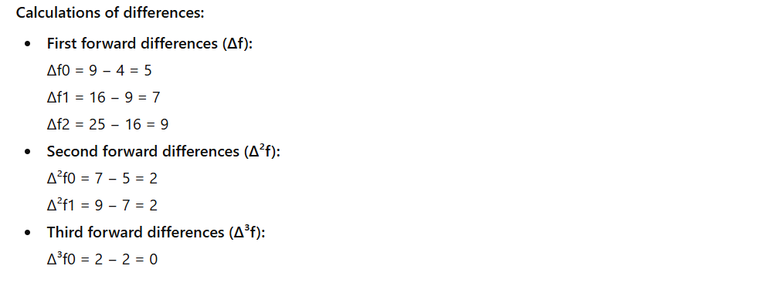

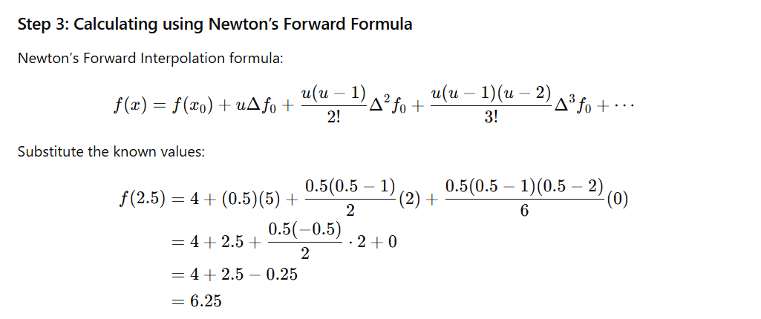



So, using Newton’s Forward Interpolation, the value of f(2.5)f(2.5)f(2.5) is estimated as 6.25, which lies accurately between the known data points. This demonstrates how the method effectively approximates function values for points near the beginning of equally spaced data.

Advantage of Newton’s Forward Interpolation

- Simple and Systematic
  - The method follows a clear step-by-step procedure: construct a forward difference table and apply the formula.
  - Easy to understand and implement, even for beginners in numerical methods.
- Efficient for Equally Spaced Data
  - Works best when the data points are equally spaced, reducing computational complexity.
  - Only the top entries of the forward difference table are required, making calculations faster.
- Easy to Compute Using Tables
  - Forward differences can be organized in a triangular table.
  - Calculations for higher-order differences are systematic and easy to manage.
- Suitable for Values Near the Beginning
  - Provides accurate estimates for points close to the first data value x0.
  - Reduces errors when interpolating near the start of the data set compared to other methods like backward or central differences.
- Flexible for Higher Accuracy
  - By including more forward differences (higher-order terms), the approximation can be made more accurate.

Discussion

Newton’s Forward Interpolation is a widely used numerical technique for estimating function values within a set of equally spaced data points. It is particularly effective when the required value lies near the beginning of the table. The method is based on the concept of finite forward differences, which approximate derivatives in a discrete form. By constructing a forward difference table, the computation of higher-order differences becomes systematic and organized. The interpolation formula is derived from the Taylor series, where derivatives are replaced by forward differences, making it suitable for tabulated data. This approach allows the estimation of unknown values accurately without knowing the exact functional relationship. Newton’s Forward Interpolation is simple, efficient, and easily computable, even for higher-order approximations. It serves as a foundational tool for other numerical methods such as backward interpolation, central differences, and polynomial fitting. Its applications span mathematics, physics, engineering, computer science, statistics, and data analysis. The method also demonstrates the practical use of discrete data to predict values at intermediate points with minimal computational effort. Overall, it provides a structured and reliable framework for numerical estimation in real-world problems.

Conclusion
Newton’s Forward Interpolation is a simple and effective method for estimating values near the first data point of equally spaced data. By using forward differences, it avoids the need for complex derivatives while maintaining accuracy. The method is systematic, efficient, and forms a strong foundation for understanding more advanced numerical techniques.

